


AB Bank Zambia

Monthly Report
January 2026

Contents
1. Executive Summary 2
1.1. Key Highlights: 2
1.1.1. Incident Volume & Trends: 2
1.1.2. Detection & Response Performance: 2
1.2. Incident Trends & Analysis: 3
1.3. High-Severity Incidents: 4
2. January Alerts & Incidents Overview 4
2.1. Overall Volume 4
2.2. Incidents Processing 5
2.3. Mean Time To Detect (MTTD) 5
3. Incidents Highlights 6
3.1. Top Incidents by type 6
3.2. Analysis of Key Incident Trends 7
3.3. High Severity 9
4. Cybersecurity Trends and Threats (January 2026) 10
4.1. Key Threats and Incidents 10
4.2. Regional Spillover and Infrastructure Risks 11
4.3. Government and Infrastructure Response 11
5. Conclusion and Recommendations 12
5.1. Recommendations 12
5.2. Conclusion 13
Appendix – Test-server Alerts 13
Total Incidents by Severity 13
Top 10 Incidents 14
High Severity Incidents 14

Executive Summary
This security report provides an in-depth analysis of security incidents, alerts, and operational activities managed by TeKnowledge for AB Bank Zambia during the reporting period (January 2026). The findings highlight key security trends, detection and response performance, and proactive measures taken to enhance the organization’s security posture.

Key Highlights:

Incident Volume & Trends:
A total of 1036 security incidents were generated in the Production environment and 0 Security incidents in the Test Environment. All incidents were processed in Microsoft Sentinel, encompassing both manually investigated cases and automated detections.
The most prevalent security events still include FortiGate Successful Login, Admin Account Logon Failure, Authentication Attempt - Default Account, User Account Modified and FortiGate Logon Failure highlighting the performance of the Security Environment on Access-Notifications to Digital assets (for both successful and failed) and User-Account Management in the Security environment.

Detection & Response Performance:
Mean Time to Detect (MTTD): 2 minutes and 4 seconds, ensuring timely identification of incidents.
Additionally, the breakdown of MTTD by severity is as follows:
High Severity: 1 minute and 22 seconds
Medium Severity: 2 minutes and 3 seconds
Informational: 3 minutes and 16 seconds

Average time to First Response: The average Time to First Response was 7 minutes. See the screenshot below for the breakdown according to the incidents’ severity.
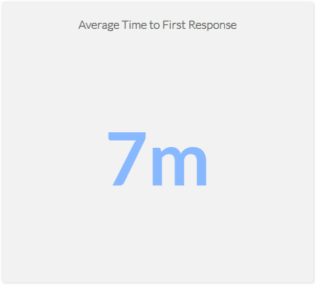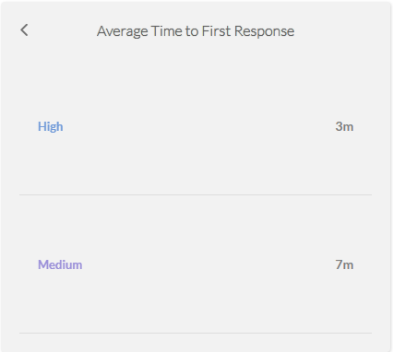
Mean Time to Resolution (MTTR): The average Mean Time to Resolution (MTTR) for this reporting period was 22 minutes. The screenshot below provides a detailed breakdown by severity.
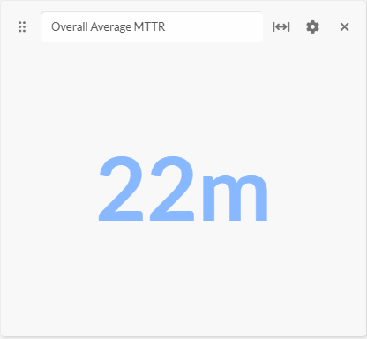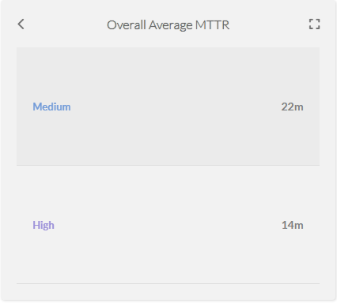

Incident Trends & Analysis:
The top recurring incident types identified in January accounted for 500 of the total incidents. These incidents were mainly tied to FortiGate Successful Login, Authentication Attempt - Default Account, FortiGate Logon Failure, User Account Modified and Monitor for keylogging activity indicating User Account Management Notifications, Access-Notification to critical Assets and suspicious activity tracking.
The most frequent alerts were related to:
- FortiGate Successful Login – 275
- Authentication Attempt - Default Account – 118
- FortiGate Logon Failure – 89
- User Account Modified – 85
- Monitor for keylogging activity - 57
All these incidents were thoroughly reviewed and escalated where necessary, helping to maintain Operational stability and security to the critical Assets.

High-Severity Incidents:
A total of 17 alerts were categorized as high severity, which entails Non Domain Controller Active Directory Replication and Preview: Possible multistage attack activities detected by Fusion. The high-severity case confirmed to be carried out by The Dedicated Service-Account for Active Directory Replication and activity of Authorized Infrastructure Administrators.

January Alerts & Incidents Overview

Overall Volume
In the month of January, a total of 1036 incidents from production environment were handled on MS Sentinel. Further breakdown in severity showed that 17 were of High Severity, 989 were of Medium Severity, and 30 Informational Incidents. This volume includes manually-processed incidents and automatically-addressed incidents: through pre-configured automation protocols.

Incidents Processing
During the reporting period, TeKnowledge successfully monitored, detected, and responded to a total of 1036 security incidents within the AB Bank Zambia production environment. The SOC team processed all incidents, ensuring a comprehensive approach to threat detection and response.

Mean Time To Detect (MTTD)
The average Mean Time to Detect (MTTD) for this reporting period was 2 minutes and 4 seconds. Average detection time for High-severity was 1 minute 22 seconds, Medium-severity was 2 minutes 3 seconds and Informational incidents were averagely detected at 3 minutes 16 seconds

Incidents Highlights

Top Incidents by type
During the reporting period, TeKnowledge monitored security incidents, identifying the most prevalent issues within your environment. Below is a breakdown of the top incident types detected:

Incident Title | Count of Title
FortiGate Successful Login | 275
Authentication Attempt - Default Account | 118
FortiGate Logon Failure | 89
User Account Modified | 85
Monitor for keylogging activity | 57
FortiGate Configuration Change | 40
rm_margaret.moola FortiClient VPN Connected | 38
rm_margaret.moola FortiClient VPN connected outside of Business Hours | 34
FortiGate UTM Alerts | 31
RM_Lameck.Kaluba FortiClient VPN Connected | 31
Grand Total | 798

Analysis of Key Incident Trends
During this reporting period, TeKnowledge identified and categorized multiple security incidents within the AB Bank Zambia production environment. The breakdown below highlights key trends, notable threat patterns, and actionable recommendations to improve detection and response capabilities
- FortiGate Successful Login (275 Incidents)
Description: This rule detects successful logins to FortiGate's management console by parsing the Syslog messages and extracting login details like user, source IP, and destination IP.
Observation: All the VPN connections were confirmed to be from legitimate and authorized users.
- Authentication Attempt-Default Account (118 Incidents)
Description: This rule monitors authentication attempts using default accounts like "Administrator," "Root," or "Guest." It searches for specific logon event types (4624, 4625, 4768, 4771, 4648, 4801) and checks if the account being used is one of the default names.
Observations: These incidents were confirmed to be generated by legitimate service accounts dedicated to specific service in the environment.
- FortiGate Logon Failure (89 Incidents)
Description: This rule detects failed login attempts on FortiGate devices' administrative interface. It parses the Syslog messages for failure events, while excluding specific benign scenarios.
Observation: These were triggered from legitimate users who made mistakes in the login password and/or ssh error due to expired token.
- User Account Modified (85 Incidents)
Description: This rule detects modifications made to user accounts in Active Directory by monitoring Event ID 4738. It focuses on changes to user account attributes and identifies the account and subject responsible for the modification
Observation: These User account modifications were confirmed to be carried out by authorized IT Systems Administrators.
- Monitor for keylogging activity (57 Incidents)
Description: This rule detects keylogging activity from Servers within the Environment.
Observation: These were triggered from legitimate users who logged in a PRTG application and no malicious activity was found.
- FortiGate Configuration Change (40 Incidents)
Description: This rule detects configuration changes on FortiGate firewalls by monitoring Syslog messages that indicate a change and extracting details such as the user and device involved.
Feedback: The incident was confirmed to be carried out by authorized IT and Network Administrators. The configuration was legitimate.
- rm_margaret.moola FortiClient VPN Connected (38 Incidents)
Description: This rule detects successful FortiClient VPN connections by parsing Syslog messages from FortiGate devices and extracting relevant user and IP information.
Observation: The user, “Margaret Moola” is an Authorized User, hence the VPN connection was an expected activity.
- rm_margaret.moola FortiClient VPN Connected outside of Business Hours (34 Incidents)
Description: This rule detects FortiClient VPN connections made outside of standard business hours (5 AM to 3 PM, Monday to Friday) by parsing Syslog from FortiGate devices.
Observation: The user, “Margaret Moola” is an Authorized User with after business hours privileges.
- FortiGate UTM Alerts (31 Incidents)
Description: This rule detects FortiGate Unified Threat Management (UTM) alerts by parsingSyslog messages that contain UTM alert indicators and identifying relevant details like source and destination IPs.
Feedback: It was discovered that the requests were from malicious scanners. And all of the requests were identified and dropped by the firewall. The Scanners were identified to be “Censys.io” and “ZGrab” scanners.
- RM_Lameck.Kaluba FortiClient VPN Connected (31 Incidents)
Description: This rule detects successful FortiClient VPN connections by parsing Syslog messages from FortiGate devices and extracting relevant user and IP information.
Observation: The user, “Lameck Kaluba” is an Authorized User, hence the VPN connection was an expected activity.

High Severity
During the reporting period, 17 high-severity incidents were recorded.
Incident Title | Count of Title
Non Domain Controller Active Directory Replication | 15
Preview: Possible multistage attack activities detected by Fusion | 2
Grand Total | 17

- Non Domain Controller Active Directory Replication (15 Incidents)
Review: This rule detects potential attempts by non-computer accounts (non domain controllers) to retrieve/synchronize an active directory object leveraging directory replication services (DRS). A Domain Controller (computer account) would usually be performing these actions in a domain environment.
On further investigation, it was discovered that this was an authorized activity of a dedicated Service Account for Azure AD Connect synchronization.

- Preview: Possible multistage attack activities detected by Fusion (2 Incidents)
Review: Microsoft Sentinel uses Fusion, a correlation engine based on scalable machine learning algorithms, to automatically detect multistage attacks by identifying combinations of anomalous behaviors and suspicious activities that are observed at various stages of the kill chain. On the basis of these discoveries, Azure Sentinel generates incidents that would otherwise be very difficult to catch. By design, these incidents are low-volume, high-fidelity, and high-severity, which is why this detection is turned ON by default.
On further investigation, it was discovered that these incidents were activities of authorized infrastructure administrators. The continuous failed activity from an Administrative account occurred due to account credential update, thereby leading to continuous failed session reconnection.

Cybersecurity Trends and Threats (January 2026)
In January 2026, Zambia's cybersecurity threat picture (as reflected in public reporting) was dominated by mobile-enabled fraud and scam infrastructure, alongside harmful online behavior targeting young people and misuse of digital communications with real-world consequences. The month also showed visible enforcement and policy traction through actions linked to the Cyber Crimes Act (2025) and child online protection programming. While there were no widely disclosed, confirmed enterprise data breaches or ransomware incidents publicly reported in Zambia dated strictly Jan 1- 31, 2026, the threat environment was clearly shaped by social engineering (fake SMS/loan offers), scam-linked SIM activity, cyberbullying, and deceptive online communications.

Key Threats and Incidents
Absence of Confirmed January Enterprise Breach/Ransomware Disclosures in Public Reports: Within Jan 1-31, 2026, the open sources reviewed did not surface widely reported Zambia-specific disclosures of ransomware incidents, major corporate data breaches, or confirmed intrusions. Public reporting in the month focused instead on fraud/scams, harmful online conduct, and enforcement actions suggesting a visibility/disclosure gap rather than a risk- free environment.
-Mobile Money/SMS Scam Threat + Scam-Linked SIM Ecosystem (High-Impact Threat)
A Jan 8, 2026 Zambia Daily Mail article emphasizes the importance of continuing the deactivation of scam-linked numbers, citing the role of fake SMS schemes and mobile-enabled fraud in victim losses, and framing the effort as protective for citizens and trust in the digital economy. This points to a persistent threat cluster centered on smishing, impersonation, and mobile money theft.
Deceptive/Unsolicited Digital Communication as an Enforcement-Visible Threat: On Jan 20, 2026, Zambia Monitor reported the arrest/charge of Miles Sampa for the offence of Transmission of Unsolicited or Deceptive Communication, referencing Section 19(1)(d) of the Cyber Crimes Act No. 4 of 2025 and alleging transmission of false information via digital channels. Regardless of the political context, this highlights an operational concern: digital communications can be weaponized to mislead, trigger public reactions, or erode trust, which overlaps with scam mechanics and influence-style abuse.
- Cyberbullying Targeting Learners (Online Harm + Account/Privacy Abuse Risk)
A Jan 7, 2026 Lusaka Times report notes government concern over a rise in cyberbullying, describing harassment and humiliation of learners through social media platforms and mobile messaging. In security terms, cyberbullying often correlates with impersonation, doxxing, coerced sharing, and account abuse, especially among minors.

Regional Spillover and Infrastructure Risks
Cross-platform fraud propagation (SMS + social apps + mobile rails): January's scam-linked SIM focus indicates Zambia's exposure to fraud campaigns that spread across SMS and
messaging/social platforms, then monetize through mobile money/payment behaviors. This creates fast-moving, high- volume victimization risk where reporting and blocking speed matter.
Low-friction social engineering remains the highest-leverage attack method: The threats highlighted in January reporting (fake SMS schemes, deceptive communications, cyberbullying) share a common driver: social engineering cheap for attackers, effective at scale, and hard to eradicate without strong identity controls, user education, and rapid reporting takedowns.
- Child online risk exposure (grooming, coercion, harmful content vectors)
UNICEF Zambia's Jan 23, 2026 press release on implementation of the National Child Online Protection Strategy (NCOP) 2025-2029 reflects recognized national risk areas affecting children online and the need for digital literacy and child- friendly reporting mechanisms a direct response to persistent online harm vectors.

Government and Infrastructure Response
Scam-number disruption as a protective control (telecom/regulator-linked mitigation): The Jan 8, 2026 reporting supports continued deactivation of scam-linked numbers as a practical national mitigation approach to reduce fraud reach and protect citizens an example of actionable "attack-surface reduction" at the telecom layer.
- Cyber Crimes Act enforcement visibility (deceptive communications offence)
The Jan 20, 2026 enforcement action explicitly references Zambia's Cyber Crimes Act No. 4 of 2025, signaling that digital deception and related abuses are being pursued through formal legal pathways.
Child online protection strategy implementation momentum: The Jan 23, 2026 UNICEF Zambia update shows operational movement around NCOP implementation, emphasizing investments in digital literacy and reporting mechanisms, which are foundational to reducing cyberbullying and exploitation risk over time posture.

Sources: UNICEF, Zambia Monitor, Daily Mail, Lusaka Times

Conclusion and Recommendations

Recommendations
Optimize Analytic Rules: Standardize entity mapping (Account, Host, IP, Process, File Hash, URL/Domain) across analytic rules to improve auto-grouping, speed up triage, reduce noise from non-production systems, and enhance reporting accuracy.
Expand SSH Detection: Develop additional analytic rules to increase visibility into SSH-based connections and activities, ensuring comprehensive coverage of remote-access behavior.
Ensure Agent Resilience: Configure all log-forwarding agents to start automatically after reboots and set service recovery options to restart on failure, preventing data gaps after maintenance or outages.
Detect Log Gaps: Setup an analytic rule that flags servers with missing or delayed log data, enabling quick identification and remediation of sources that stop sending events.
Correct “Heartbeat Missing” Rule Configuration: Update the Rule Period from 30 minutes to 6–12 hours to broaden detection coverage and configure Event Grouping to “Group all events into a single alert”.
Emphasis on WithSecure EDR Integration with Microsoft Sentinel: Integrating WithSecure EDR with Microsoft Sentinel is recommended to improve security visibility and efficiency. This integration centralizes endpoint and cloud workload security events into a single monitoring platform, enhancing situational awareness and event correlation. By unifying security data within Sentinel, organizations can streamline investigations, automate responses, and accelerate incident detection and remediation, ultimately strengthening overall threat response capabilities.

Conclusion
The January 2026 reporting period marked a significant step forward in the security operations of AB Bank Zambia, with TeKnowledge continuing to provide dedicated 24/7 monitoring, incident detection, and rapid response through the Microsoft Sentinel platform. A total of 1036 alerts were processed a significant increase from the previous month reflecting the need for optimization of the analytical rules in the environment.
The most detected threats included FortiGate Successful Login, Authentication Attempt - Default Account, FortiGate Logon Failure, User Account Modified and Monitor for keylogging activity underscoring the need for sustained vigilance in identity/access management as well as operational status of critical assets.
TeKnowledge’s SOC demonstrated high operational efficiency, with the following key performance:
- Mean Time to Detect (MTTD): 2 minutes and 4 seconds
- Average Time to First Response: 7 minutes (Medium 7minutes)
- Average Mean Time to Resolution: 22 minutes

17 high-severity incidents were recorded during this period.
As we move forward, TeKnowledge remains dedicated to strengthening your organization’s defences through:
- Continuous monitoring, rapid threat detection and Incident escalation
- Strategic improvements to rule coverage and incident handling workflows

We appreciate the trust placed in TeKnowledge to safeguard AB Bank Zambia’s digital environment and look forward to our continued partnership in building a more secure and resilient infrastructure.

Appendix – Test-server Alerts
This section documents alerts generated on test servers (non-critical) during the reporting period. These events are excluded from SLA/MTTR metrics and captured for transparency and auditability.

Total Incidents by Severity
Severity | Count of Severity
Medium | 0
Grand Total | 0

Top 10 Incidents
Title | Sum by Title
User Added to Critical Group | 0
Grand Total | 0

High Severity Incidents
Title | Count of Title
Nil | 0
Grand Total | 0

